

LAB 1
Hangman(Simple Intelligent Agent)

Submitted by: Submitted to:
Nabin Katwal Deepak Bhatt
Class of 2022 Artificial Intelligence
Roll No: 824

INTRODUCTION
An intelligent agent (IA) is an entity that makes a decision that enables artificial intelligence to be put into action. It can also be described as a software entity that conducts operations in the place of users or programs after sensing the environment. It uses actuators to initiate action in that environment. This agent has some level of autonomy that allows it to perform specific, predictable, and repetitive tasks for users or applications. It’s also termed as ‘intelligent’ because of its ability to learn during the process of performing tasks. The two main functions of intelligent agents include perception and action. Perception is done through sensors while actions are initiated through actuators. Intelligent agents consist of sub-agents that form a hierarchical structure. Lower-level tasks are performed by these sub-agents. The higher-level agents and lower-level agents form a complete system that can solve difficult problems through intelligent behaviors or responses.
PROGRAM CODE
import random

class Hangman:
def __init__(self):
self.chance = 6;
self.guessed = []
self.wrong = []
self.guess_list = []
self.letter_list = []
self.level = 1

def get_word(self):
word_list = ['Catfish','Luffy','Artificial']
return random.choice(word_list).upper()

def difficulty(self):
self.level = int(input("Select difficulty level: (1/2/3)->"))
return self.level

def logic(self):
self.difficulty()
word = self.get_word()
self.letter_list = [word[i] for i in range(0, len(word))]
self.guess_list = ['_' for i in range(0,len(word))]
if self.level == 1:
word_hint, word_hint1, word_hint2 = random.randint(1, len(self.letter_list)-1), random.randint(1, len(self.letter_list)-1), random.randint(1, len(self.letter_list)-1)
if self.level == 2:
word_hint, word_hint1 = random.randint(1, len(self.letter_list)-1), random.randint(1, len(self.letter_list)-1)
if self.level == 3:
word_hint = random.randint(1, len(self.letter_list)-1)
for i in range(0, len(self.letter_list)):
if self.level == 1:
self.guess_list[word_hint] = self.letter_list[word_hint]
self.guess_list[word_hint1] = self.letter_list[word_hint1]
self.guess_list[word_hint2] = self.letter_list[word_hint2]
if self.level == 2:
self.guess_list[word_hint] = self.letter_list[word_hint]
self.guess_list[word_hint1] = self.letter_list[word_hint1]
if self.level == 3:
self.guess_list[word_hint] = self.letter_list[word_hint]

def play(self):
index_alphabet = ''
self.logic()
print("HANGMAN")
print(f"Your word to guess is: {self.guess_list}")
word = ''
while self.chance != 0:
print(f"Progress: {self.guess_list}")
print(f"Chances left: {self.chance}")
word = (input("Enter your choice->")).upper()
print(f"you entered: {word}")
if word in self.wrong:
print("You already guessed this letter. This doesn't count.")
self.chance += 1
if word in self.letter_list:
self.guessed.append(word)
index_alphabet = self.letter_list.index(word)
if word in self.guess_list:
# self.letter_list.remove(index_alphabet)
pass
else:
self.guess_list[index_alphabet] = self.letter_list[index_alphabet]
if '_' not in self.guess_list:
print("You won")
print(f"The word was {self.get_word()}")
break
else:
self.wrong.append(word)
self.chance -= 1
if self.chance == 1:
print("Last Chance. Exiting at next wrong guess.")
print("\n")
print(self.guessed)
print(self.wrong)

if __name__ == "__main__":
hangman = Hangman()
# hangman.logic()
hangman.play()
OUTPUT
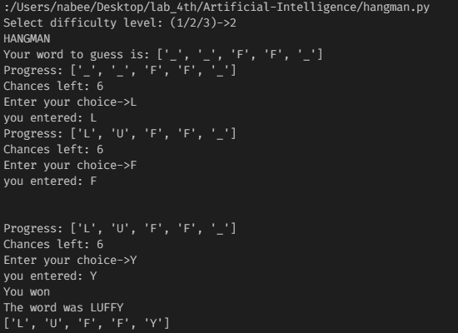

LAB 2
Depth first search and Breadth first search

Submitted by: Submitted to:
Nabin Katwal Deepak Bhatt
Class of 2022 Artificial Intelligence
Roll No: 824

Depth first search
Depth-first search is recursive algorithm for traversing a tree or graph data structure. It is called the depth-first search because it starts from the root node and follows each path to its greatest depth node before moving to the next path. DFS uses a stack data structure for its implementation. The process of the DFS algorithm is similar to the BFS algorithm.
Advantage:
- DFS requires very less memory as it only needs to store a stack of the nodes on the path from root node to the current node.
- It takes less time to reach to the goal node than BFS algorithm (if it traverses in the right path).
Disadvantage:
- There is the possibility that many states keep re-occurring, and there is no guarantee of finding the solution.
- DFS algorithm goes for deep down searching and sometime it may go to the infinite loop.
Breadth first search
Breadth-first search is the most common search strategy for traversing a tree or graph. This algorithm searches breadthwise in a tree or graph, so it is called breadth-first search. BFS algorithm starts searching from the root node of the tree and expands all successor node at the current level before moving to nodes of next level. The breadth-first search algorithm is an example of a general-graph search algorithm. Breadth-first search implemented using FIFO queue data structure.
Advantages:
- BFS will provide a solution if any solution exists.
- If there are more than one solutions for a given problem, then BFS will provide the minimal solution which requires the least number of steps.
Disadvantages:
- It requires lots of memory since each level of the tree must be saved into memory to expand the next level.
- BFS needs lots of time if the solution is far away from the root node.

Depth first search
PROGRAM CODE
from collections import defaultdict

class Graph:
def __init__(self):
self.graph = defaultdict(list)

def addEdge(self, u, v):
self.graph[u].append(v)

def DFSUtil(self, v, visited):
visited.add(v)
print(v, end=' ')
for neighbour in self.graph[v]:
if neighbour not in visited:
self.DFSUtil(neighbour, visited)

def DFS(self, v):
visited = set()
self.DFSUtil(v, visited)

g = Graph()
g.addEdge(0, 1)
g.addEdge(0, 2)
g.addEdge(1, 2)
g.addEdge(2, 0)
g.addEdge(2, 3)
g.addEdge(3, 3)

print("Following is DFS from (starting from vertex 2)")
g.DFS(2)
OUTPUT
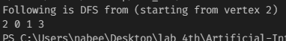

Breadth first search
PROGRAM CODE
from collections import defaultdict

class Graph:
def __init__(self):
self.graph = defaultdict(list)

def addEdge(self,u,v):
self.graph[u].append(v)

def BFS(self, s):
visited = [False] * (max(self.graph) + 1)
queue = []

queue.append(s)
visited[s] = True

while queue:
s = queue.pop(0)
print (s, end = " ")
for i in self.graph[s]:
if visited[i] == False:
queue.append(i)
visited[i] = True

g = Graph()
g.addEdge(0, 1)
g.addEdge(0, 2)
g.addEdge(1, 2)
g.addEdge(2, 0)
g.addEdge(2, 3)
g.addEdge(3, 3)

print ("Following is Breadth First Traversal"
" (starting from vertex 2)")
g.BFS(2)

OUTPUT

LAB 3
Greedy Best First, A*

Submitted by: Submitted to:
Nabin Katwal Deepak Bhatt
Class of 2022 Artificial Intelligence
Roll No: 824

INTRODUCTION
Greedy Best First
Greedy best-first search algorithm always selects the path which appears best at that moment. It is the combination of depth-first search and breadth-first search algorithms. It uses the heuristic function and search. Best-first search allows us to take the advantages of both algorithms. With the help of best-first search, at each step, we can choose the most promising node. In the best first search algorithm, we expand the node which is closest to the goal node and the closest cost is estimated by heuristic function, i.e.
F(n) = g(n)
Advantages:
- Best first search can switch between BFS and DFS by gaining the advantages of both the algorithms.
- This algorithm is more efficient than BFS and DFS algorithms.

Disadvantages:
- It can behave as an unguided depth-first search in the worst case scenario.
- It can get stuck in a loop as DFS.
- This algorithm is not optimal.
A Star
A* search is the most commonly known form of best-first search. It uses heuristic function h(n), and cost to reach the node n from the start state g(n). It has combined features of UCS and greedy best-first search, by which it solve the problem efficiently. A* search algorithm finds the shortest path through the search space using the heuristic function. This search algorithm expands less search tree and provides optimal result faster. A* algorithm is similar to UCS except that it uses g(n)+h(n) instead of g(n).
In A* search algorithm, we use search heuristic as well as the cost to reach the node. Hence we can combine both costs as following, and this sum is called as a fitness number.
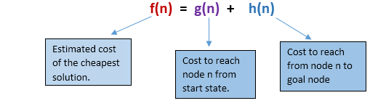
Advantages:
- A* search algorithm is the best algorithm than other search algorithms.
- A* search algorithm is optimal and complete.
- This algorithm can solve very complex problems.

Disadvantages:
- It does not always produce the shortest path as it mostly based on heuristics and approximation.
- A* search algorithm has some complexity issues.
- The main drawback of A* is memory requirement as it keeps all generated nodes in the memory, so it is not practical for various large-scale problems.

Greedy Best First
PROGRAM CODE
from queue import PriorityQueue
v = 14
graph = [[] for i in range(v)]

def best_first(source, target, n):
Visited = [0]*n
visited = True
queue = PriorityQueue()
queue.put((0, source))
while queue.empty() == False:
u = queue.get()[1]
print(u, end = " ")
if u == target:
break

for v,c in graph[u]:
if Visited[v] == False:
Visited[v] = True
queue.put((c,v))
print()

def add_edge(x, y, cost):
graph[x].append((y, cost))
graph[y].append((x, cost))

add_edge(0, 1, 3)
add_edge(0, 2, 6)
add_edge(0, 3, 5)
add_edge(1, 4, 9)
add_edge(1, 5, 8)
add_edge(2, 6, 12)
add_edge(2, 7, 14)
add_edge(3, 8, 7)
add_edge(8, 9, 5)
add_edge(8, 10, 6)
add_edge(9, 11, 1)
add_edge(9, 12, 10)
add_edge(9, 13, 2)

source = 0
target = 9
best_first(source, target, v)

OUTPUT
A Star
PROGRAM CODE
def aStarAlgo(start_node, stop_node):

open_set = set(start_node)
closed_set = set()
g = {}
parents = {}
g[start_node] = 0
parents[start_node] = start_node

while len(open_set) > 0:
n = None
for v in open_set:
if n == None or g[v] + heuristic(v) < g[n] + heuristic(n):
n = v

if n == stop_node or Graph_nodes[n] == None:
pass
else:
for (m, weight) in get_neighbors(n):
if m not in open_set and m not in closed_set:
open_set.add(m)
parents[m] = n
g[m] = g[n] + weight

else:
if g[m] > g[n] + weight:
g[m] = g[n] + weight
parents[m] = n
if m in closed_set:
closed_set.remove(m)
open_set.add(m)

if n == None:
print('Path does not exist!')
return None

if n == stop_node:
path = []

while parents[n] != n:
path.append(n)
n = parents[n]

path.append(start_node)

path.reverse()

print('Path found: {}'.format(path))
return path

open_set.remove(n)
closed_set.add(n)

print('Path does not exist!')
return None

def get_neighbors(v):
if v in Graph_nodes:
return Graph_nodes[v]
else:
return None

def heuristic(n):
H_dist = {
'A': 11,
'B': 6,
'C': 99,
'D': 1,
'E': 7,
'G': 0,

}

return H_dist[n]

Graph_nodes = {
'A': [('B', 2), ('E', 3)],
'B': [('C', 1),('G', 9)],
'C': None,
'E': [('D', 6)],
'D': [('G', 1)],

}
aStarAlgo('A', 'G')
OUTPUT

LAB 4
Constraint Satisfaction Problem

Submitted by: Submitted to:
Nabin Katwal Deepak Bhatt
Class of 2022 Artificial Intelligence
Roll No: 824

INTRODUCTION
Water Jug Problem
In the water jug problem in Artificial Intelligence, we are provided with two jugs: one having the capacity to hold 3 gallons of water and the other has the capacity to hold 4 gallons of water. There is no other measuring equipment available and the jugs also do not have any kind of marking on them. So, the agent’s task here is to fill the 4-gallon jug with 2 gallons of water by using only these two jugs and no other material. Initially, both our jugs are empty.
N Queen problem
N - Queens problem is to place n - queens in such a manner on an n x n chessboard that no queens attack each other by being in the same row, column or diagonal.
It can be seen that for n =1, the problem has a trivial solution, and no solution exists for n =2 and n =3. So first we will consider the 4 queens problem and then generate it to n - queens problem.
Given a 4 x 4 chessboard and number the rows and column of the chessboard 1 through 4.
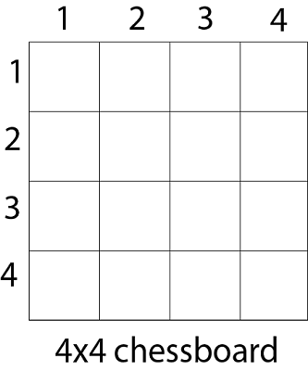
Since, we have to place 4 queens such as q1 q2 q3 and q4 on the chessboard, such that no two queens attack each other. In such a conditional each queen must be placed on a different row, i.e., we put queen "i" on row "i."
Now, we place queen q1 in the very first acceptable position (1, 1). Next, we put queen q2 so that both these queens do not attack each other. We find that if we place q2 in column 1 and 2, then the dead end is encountered. Thus the first acceptable position for q2 in column 3, i.e. (2, 3) but then no position is left for placing queen 'q3' safely. So we backtrack one step and place the queen 'q2' in (2, 4), the next best possible solution. Then we obtain the position for placing 'q3' which is (3, 2). But later this position also leads to a dead end, and no place is found where 'q4' can be placed safely. Then we have to backtrack till 'q1' and place it to (1, 2) and then all other queens are placed safely by moving q2 to (2, 4), q3 to (3, 1) and q4 to (4, 3). That is, we get the solution (2, 4, 1, 3). This is one possible solution for the 4-queens problem. For another possible solution, the whole method is repeated for all partial solutions. The other solutions for 4 - queens problems is (3, 1, 4, 2) i.e.
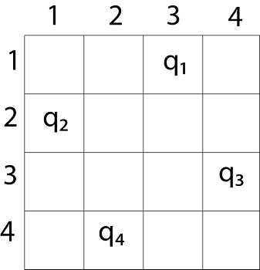
The implicit tree for 4 - queen problem for a solution (2, 4, 1, 3) is as follows:
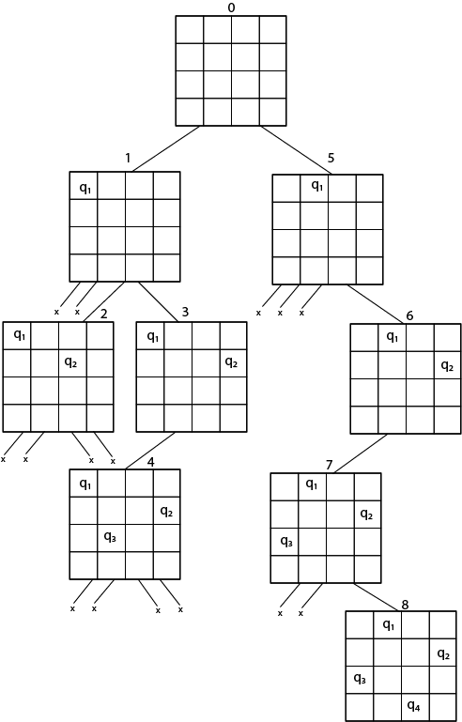
But we can use backtracking method to generate the necessary node and stop if the next node violates the rule, i.e., if two queens are attacking. 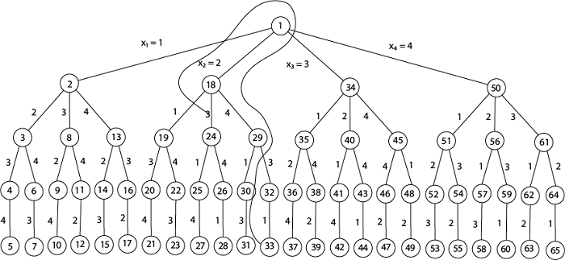
It can be seen that all the solutions to the 4 queens problem can be represented as 4 - tuples (x1, x2, x3, x4) where xi represents the column on which queen "qi" is placed.
One possible solution for 8 queens problem is shown in fig:
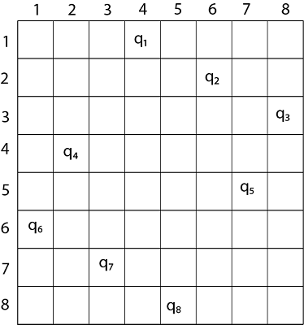
Water jug problem
PROGRAM CODE
from collections import deque

def BFS(a, b, target):
m = {}
isSolvable = False
path = []
q = deque()
q.append((0, 0))

while (len(q) > 0):
u = q.popleft()

if ((u[0], u[1]) in m):
continue

if ((u[0] > a or u[1] > b or
u[0] < 0 or u[1] < 0)):
continue

path.append([u[0], u[1]])

m[(u[0], u[1])] = 1

if u[0] == target or u[1] == target:
isSolvable = True

if (u[0] == target):
if (u[1] != 0):

path.append([u[0], 0])
else:
if (u[0] != 0):

path.append([0, u[1]])

sz = len(path)
for i in range(sz):
print("(", path[i][0], ",",
path[i][1], ")")
break

q.append([u[0], b]) # Fill Jug2
q.append([a, u[1]]) # Fill Jug1

for ap in range(max(a, b) + 1):

# Pour amount ap from Jug2 to Jug1
c = u[0] + ap
d = u[1] - ap

# Check if this state is possible or not
if (c == a or (d == 0 and d >= 0)):
q.append([c, d])

# Pour amount ap from Jug 1 to Jug2
c = u[0] - ap
d = u[1] + ap

# Check if this state is possible or not
if ((c == 0 and c >= 0) or d == b):
q.append([c, d])

q.append([a, 0])
q.append([0, b])

if (not isSolvable):
print ("No solution")

if __name__ == "__main__":
a,b,target = 4,3,1
print("Path from one initial state to solution state ::")
BFS(a, b, target)

OUTPUT
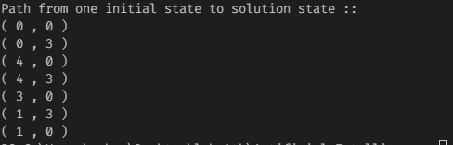
N Queen Problem
PROGRAM CODE
def isSafe(mat, r,c):
for i in range(r):
if mat[i][c] == 'Q':
return False

(i,j) = (r,c)
while i >= 0 and j>= 0:
if mat[i][j] == 'Q':
return False
i -= 1
j -= 1

(i, j) = (r, c)
while i >= 0 and j < N:
if mat[i][j] == 'Q':
return False
i -= 1
j += 1

return True

def printSolution(mat):
for i in range(N):
print(mat[i])
print()

def nQueen(mat, r):
if r==N:
printSolution(mat)
return

for i in range(N):
if isSafe(mat, r, i):
mat[r][i] = 'Q'
nQueen(mat, r+1)
mat[r][i] = '-'

if __name__ == '__main__':
N = 8
mat = [['-' for x in range(N)] for y in range(N)]
nQueen(mat, 0)

OUTPUT
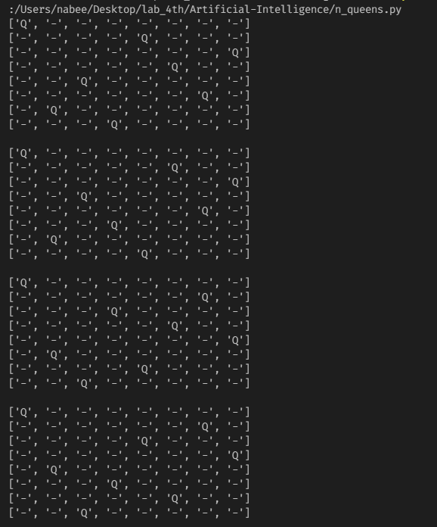
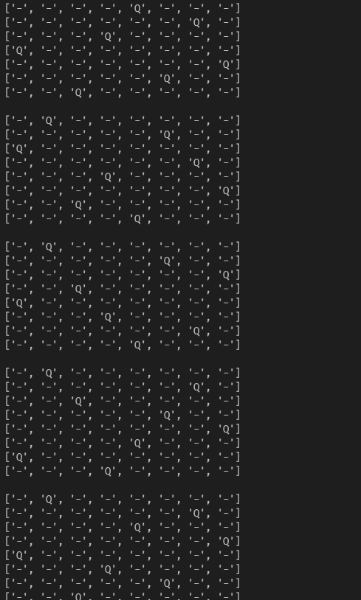

LAB 5
Simple Chat Bot

Submitted by: Submitted to:
Nabin Katwal Deepak Bhatt
Class of 2022 Artificial Intelligence
Roll No: 824

INTRODUCTION
Humans claim that how intelligence is achieved-not by purely reflect mechanisms but by process of reasoning that operate on internal representation of knowledge. In AI this techniques for intelligence are present in Knowledge Based Agents.
Knowledge-based agents have explicit representation of knowledge that can be reasoned. They maintain internal state of knowledge, reason over it, update it and perform actions accordingly. These agents act intelligently according to requirements.
Knowledge based agents give the current situation in the form of sentences. They have complete knowledge of current situation of mini-world and its surroundings. These agents manipulate knowledge to infer new things at “Knowledge level”.
A knowledge-based system has following features:
Knowledge base (KB): It is the key component of a knowledge-based agent. These deal with real facts of world. It is a mixture of sentences which are explained in knowledge representation language.
Inference Engine (IE): It is knowledge-based system engine used to infer new knowledge in the system.
PROGRAM CODE
import random

def respond(message):
if message in responses:
bot_message = random.choice(responses[message])
else:
bot_message = random.choice(responses["default"])

return bot_message

def related(x_text):
if "name" in x_text:
y_text = "What's your name?"
elif "weather" in x_text:
y_text = "What's today's weather?"
elif "robot" in x_text:
y_text = "Are you a robot?"
elif "how are" in x_text:
y_text = "How are you?"
else:
y_text = ""

return y_text

def send_message(message):
print(user_template.format(message))
response = respond(message)
print(bot_template.format(response))

def start_bot():
while 1:
my_input = input()
my_input = my_input.lower()
related_text = related(my_input)
send_message(related_text)

if my_input == "exit" or my_input == "stop":
break

if __name__ == "__main__":
print("BOT: What do you want me to call you?")
user_name = input()

bot_template = "BOT : {0}"
user_template = user_name + " : {0}"

name = "Bot"
weather = "rainy"
mood = "Happy"

responses = {
"What's your name?":[
"They call me {0}".format(name),
"I usually go by {0}".format(name),
"My name is the {0}".format(name)],
"What's today's weather?":[
f"The weather is {weather}.",
f"It's {weather} today.",
f"Let me check, it looks {weather} today."
],
"Are you a robot?":[
"What do you think?",
"Maybe yes, Maybe no!",
"Yes, I am a robot with human feelings."
],
"How are you?":[
f"I am feeling {mood}",
f"{mood}! How about you?",
f"I am {mood}! How about yourself?"
],
"":[
"Hey!, are you there?",
"What do you mean by saying nothing?",
"Sometimes saying nothing tells a lot :)"
],
"default":[
"This is a default message"
]
}

start_bot()
OUTPUT
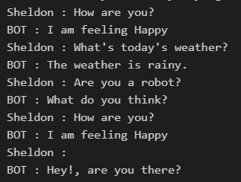

LAB 6
Naïve Bayes Implementation

Submitted by: Submitted to:
Nabin Katwal Deepak Bhatt
Class of 2022 Artificial Intelligence
Roll No: 824

INTRODUCTION
A naive Bayes classifier uses probability theory to classify data. Naive Bayes classifier algorithms make use of Bayes' theorem. The key insight of Bayes' theorem is that the probability of an event can be adjusted as new data is introduced.
What makes a naive Bayes classifier naive is its assumption that all attributes of a data point under consideration are independent of each other. A classifier sorting fruits into apples and oranges would know that apples are red, round and are a certain size, but would not assume all these things at once. Oranges are round too, after all.
A naive Bayes classifier is not a single algorithm, but a family of machine learning algorithms that make uses of statistical independence. These algorithms are relatively easy to write and run more efficiently than more complex Bayes algorithms.
The most popular application is spam filters. A spam filter looks at email messages for certain key words and puts them in a spam folder if they match.
Despite the name, the more data it gets, the more accurate a naive Bayes classifier becomes, such as from a user flagging email messages in an inbox for spam.
PROGRAM CODE
Note: The following code uses Iris dataset from Scikit library
import math
import random
import csv

def encode_class(mydata):
classes = []
for i in range(len(mydata)):
if mydata[i][-1] not in classes:
classes.append(mydata[i][-1])

for i in range(len(classes)):
for j in range(len(mydata)):
if mydata[j][-1] == classes[i]:
mydata[j][-1] = i
return mydata

def splitting(mydata, ratio):
train_num = int(len(mydata) * ratio)
train = []
test = list(mydata)
while len(train) < train_num:
index = random.randrange(len(test))
train.append(test.pop(index))
return train, test

def groupUnderClass(mydata):
dict = {}
for i in range(len(mydata)):
if mydata[i][-1] not in dict:
dict[mydata[i][-1]] = []
dict[mydata[i][-1]].append(mydata[i])
return dict

def mean(numbers):
return sum(numbers) / float(len(numbers))

def std_dev(numbers):
avg = mean(numbers)
variance = sum([pow(x-avg,2) for x in numbers])/float(len(numbers)-1)
return math.sqrt(variance)

def meanAndStdDev(mydata):
info = [(mean(attribute), std_dev(attribute)) for attribute in zip(*mydata)]
del info[-1]
return info

def meanAndStdDevForClass(mydata):
info = {}
dict = groupUnderClass(mydata)
for classValue, instances in dict.items():
info[classValue] = meanAndStdDev(instances)
return info

def calculateGaussianProbability(x, mean, stdev):
expo = math.exp(-(math.pow(x-mean, 2)/(2*math.pow(stdev,2))))
return (1/(math.sqrt(2*math.pi)*stdev))*expo

def calculateClassProbabilites(info, test):
probabilites = {}
for classValue, classSummaries in info.items():
probabilites[classValue] = 1
for i in range(len(classSummaries)):
mean, std_dev = classSummaries[i]
x = test[i]
probabilites[classValue] *= calculateGaussianProbability(x, mean, std_dev)
return probabilites

def predict(info, test):
probabilites = calculateClassProbabilites(info, test)
bestLabel, bestProb = None, -1
for classValue, probability in probabilites.items():
if bestLabel is None or probability > bestProb:
bestProb = probability
bestLabel = classValue
return bestLabel

def getPredictions(info, test):
predictions = []
for i in range(len(test)):
result = predict(info, test[i])
predictions.append(result)
return predictions

def accuracy_rate(test, predictions):
correct = 0
for i in range(len(test)):
if test[i][-1] == predictions[i]:
correct += 1
return (correct / float(len(test))) * 100.0

if __name__ == '__main__':
filename = r'D:\Fourth Sem\AI\Artificial-Intelligence\naive_bayes\Iris.csv'
mydata = csv.reader(open(filename, "rt"))
mydata = list(mydata)
mydata = encode_class(mydata)
for i in range(len(mydata)):
mydata[i] = [float(x) for x in mydata[i]]

ratio = 0.7
train_data, test_data = splitting(mydata, ratio)
print('Total number of examples are: ', len(mydata))
print('Out of these, training set is: ', len(train_data))
print('Test set is: ', len(test_data))

info = meanAndStdDevForClass(train_data)

predictions = getPredictions(info, test_data)
accuracy = accuracy_rate(test_data, predictions)
print("Model's accuracy is: ",accuracy)
OUTPUT
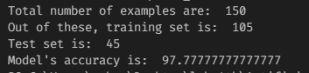

LAB 7
Neural Network

Submitted by: Submitted to:
Nabin Katwal Deepak Bhatt
Class of 2022 Artificial Intelligence
Roll No: 824

INTRODUCTION
A neural network is a series of algorithms that endeavors to recognize underlying relationships in a set of data through a process that mimics the way the human brain operates. In this sense, neural networks refer to systems of neurons, either organic or artificial in nature. Neural networks can adapt to changing input; so the network generates the best possible result without needing to redesign the output criteria. The concept of neural networks, which has its roots in artificial intelligence, is swiftly gaining popularity in the development of trading systems.
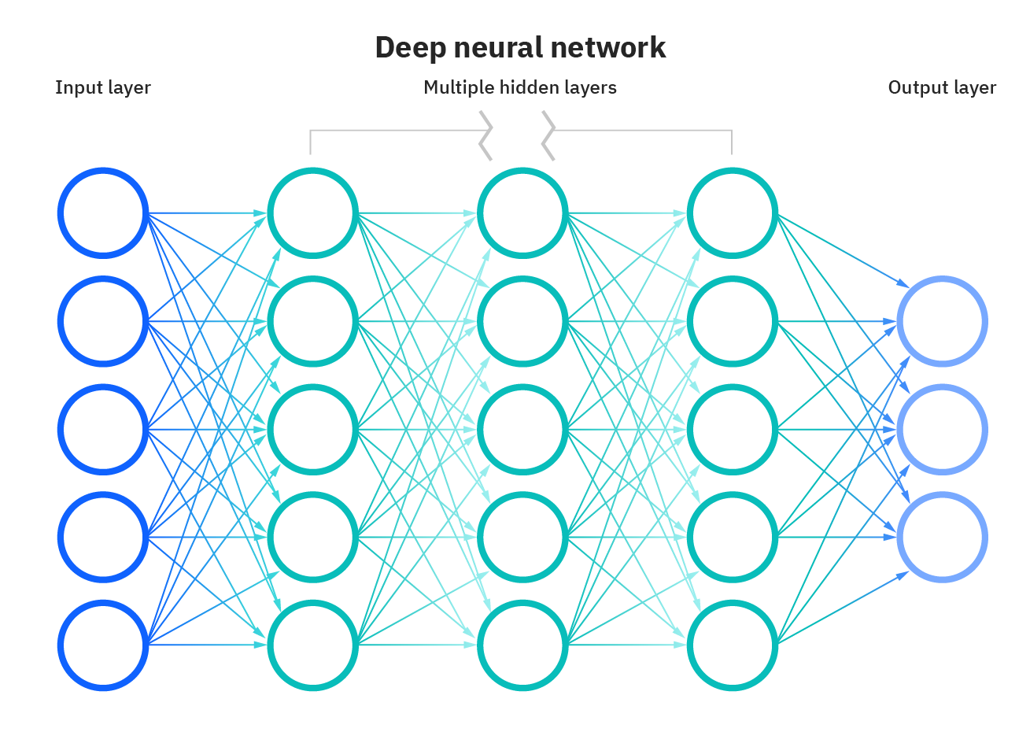
Realization of AND Gate
PROGRAM CODE
import numpy as np
from matplotlib import pyplot as plt
import seaborn as sns

def sigmoid(z):
return 1/(1+np.exp(-z))

def initializeParameters(inputFeatures, neuronsInHiddenLayers, outputFeatures):
W1 = np.random.randn(neuronsInHiddenLayers, inputFeatures)
W2 = np.random.randn(outputFeatures, neuronsInHiddenLayers)
b1 = np.zeros((neuronsInHiddenLayers, 1))
b2 = np.zeros((outputFeatures, 1))

parameters = {
"W1":W1,
"b1":b1,
"W2":W2,
"b2":b2
}

return parameters

def forwardPropagation(X, Y, parameters):
m = X.shape[1]
W1 = parameters["W1"]
W2 = parameters["W2"]
b1 = parameters["b1"]
b2 = parameters["b2"]

Z1 = np.dot(W1, X) + b1
A1 = sigmoid(Z1)
Z2 = np.dot(W2, A1) + b2
A2 = sigmoid(Z2)

cache = (Z1, A1, W1, b1, Z2, A2, W2, b2)
logprobs = np.multiply(np.log(A2), Y) + np.multiply(np.log(1-A2), (1-Y))
cost = -np.sum(logprobs) / m
return cost, cache, A2

def backwardPropagation(X, Y, cache):
m = X.shape[1]
(Z1, A1, W1, b1, Z2, A2, W2, b2) = cache

dZ2 = A2-Y
dW2 = np.dot(dZ2, A1.T)/m
db2 = np.sum(dZ2, axis=1, keepdims = True) / m

dA1 = np.dot(W2.T, dZ2)
dZ1 = np.multiply(dA1, A1*(1-A1))
dW1 = np.dot(dZ1, X.T)/m
db1 = np.sum(dZ1, axis = 1, keepdims=True) / m

gradients = {
"dZ2":dZ2,
"dW2":dW2,
"db2":db2,
"dZ1":dZ1,
"dW1":dW1,
"db1":db1
}

return gradients

def updateParameters(parameters, gradients, learningRate):
parameters["W1"] = parameters["W1"]-learningRate * gradients["dW1"]
parameters["W2"]=parameters["W2"]-learningRate*gradients["dW2"]
parameters["b1"] = parameters["b1"] - learningRate * gradients["db1"]
parameters["b2"] = parameters["b2"] - learningRate * gradients["db2"]
return parameters

X = np.array([[0,0,1,1],[0,1,0,1]])
Y = np.array([[0,0,0,1]])

neuronsInHiddenLayers = 2
inputFeatures = X.shape[0]
outputFeatures = Y.shape[0]
parameters = initializeParameters(inputFeatures, neuronsInHiddenLayers, outputFeatures)
epoch = 100000
learningRate = 0.01
losses = np.zeros((epoch, 1))

for i in range(epoch):
losses[i,0], cache, A2 = forwardPropagation(X, Y, parameters)
gradients = backwardPropagation(X, Y, cache)
parameters = updateParameters(parameters, gradients, learningRate)
print(f"Epoch: {i}, learning rate: {learningRate}, {gradients}")

plt.figure()
plt.plot(losses)
plt.xlabel("EPOCHS")
plt.ylabel("Loss value")
plt.show()

X = np.array([[0,0,1,1],[0,1,0,1]])
cost, _, A2 = forwardPropagation(X, Y, parameters)
prediction = (A2 > 0.5) * 1.0
print(prediction)

OUTPUT
After training for 10, 000 episodes. The following results were obtained
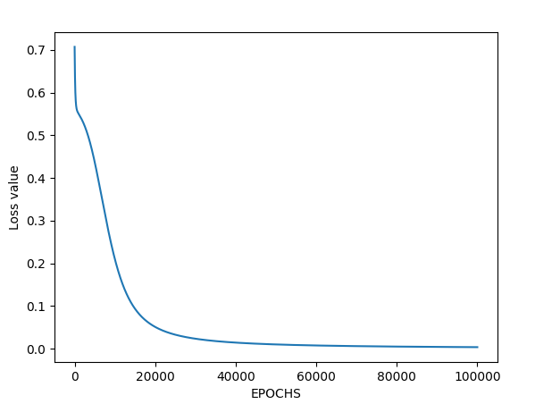
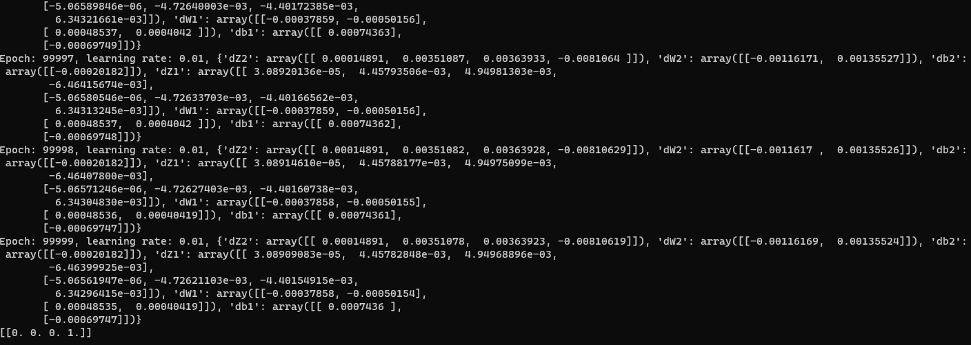

Realization of OR Gate
PROGRAM CODE
import numpy as np
from matplotlib import pyplot as plt
import seaborn as sns

def sigmoid(z):
return 1/(1+np.exp(-z))

def initializeParameters(inputFeatures, neuronsInHiddenLayers, outputFeatures):
W1 = np.random.randn(neuronsInHiddenLayers, inputFeatures)
W2 = np.random.randn(outputFeatures, neuronsInHiddenLayers)
b1 = np.zeros((neuronsInHiddenLayers, 1))
b2 = np.zeros((outputFeatures, 1))

parameters = {
"W1":W1,
"b1":b1,
"W2":W2,
"b2":b2
}

return parameters

def forwardPropagation(X, Y, parameters):
m = X.shape[1]
W1 = parameters["W1"]
W2 = parameters["W2"]
b1 = parameters["b1"]
b2 = parameters["b2"]

Z1 = np.dot(W1, X) + b1
A1 = sigmoid(Z1)
Z2 = np.dot(W2, A1) + b2
A2 = sigmoid(Z2)

cache = (Z1, A1, W1, b1, Z2, A2, W2, b2)
logprobs = np.multiply(np.log(A2), Y) + np.multiply(np.log(1-A2), (1-Y))
cost = -np.sum(logprobs) / m
return cost, cache, A2

def backwardPropagation(X, Y, cache):
m = X.shape[1]
(Z1, A1, W1, b1, Z2, A2, W2, b2) = cache

dZ2 = A2-Y
dW2 = np.dot(dZ2, A1.T)/m
db2 = np.sum(dZ2, axis=1, keepdims = True) / m

dA1 = np.dot(W2.T, dZ2)
dZ1 = np.multiply(dA1, A1*(1-A1))
dW1 = np.dot(dZ1, X.T)/m
db1 = np.sum(dZ1, axis = 1, keepdims=True) / m

gradients = {
"dZ2":dZ2,
"dW2":dW2,
"db2":db2,
"dZ1":dZ1,
"dW1":dW1,
"db1":db1
}

return gradients

def updateParameters(parameters, gradients, learningRate):
parameters["W1"] = parameters["W1"]-learningRate * gradients["dW1"]
parameters["W2"]=parameters["W2"]-learningRate*gradients["dW2"]
parameters["b1"] = parameters["b1"] - learningRate * gradients["db1"]
parameters["b2"] = parameters["b2"] - learningRate * gradients["db2"]
return parameters

X = np.array([[0, 0, 1, 1], [0, 1, 0, 1]])
Y = np.array([[0, 1, 1, 1]])

neuronsInHiddenLayers = 2
inputFeatures = X.shape[0]
outputFeatures = Y.shape[0]
parameters = initializeParameters(inputFeatures, neuronsInHiddenLayers, outputFeatures)
epoch = 100000
learningRate = 0.01
losses = np.zeros((epoch, 1))

for i in range(epoch):
losses[i,0], cache, A2 = forwardPropagation(X, Y, parameters)
gradients = backwardPropagation(X, Y, cache)
parameters = updateParameters(parameters, gradients, learningRate)
print(f"Epoch: {i}, learning rate: {learningRate}, {gradients}")

plt.figure()
plt.plot(losses)
plt.xlabel("EPOCHS")
plt.ylabel("Loss value")
plt.show()

X = np.array([[0, 0, 1, 1], [0, 1, 0, 1]])
cost, _, A2 = forwardPropagation(X, Y, parameters)
prediction = (A2 > 0.5) * 1.0
print(prediction)

OUTPUT
After training for 10,000 episodes, following results were obtained.
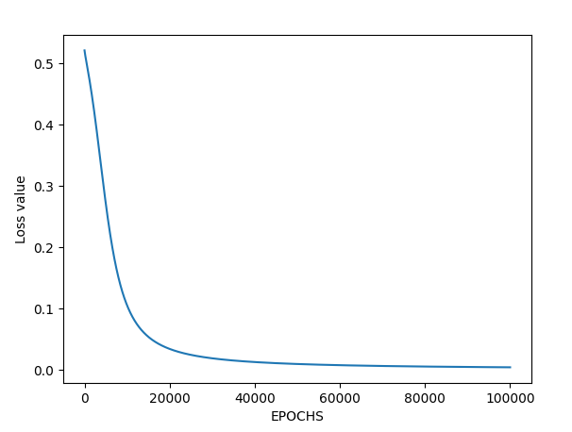
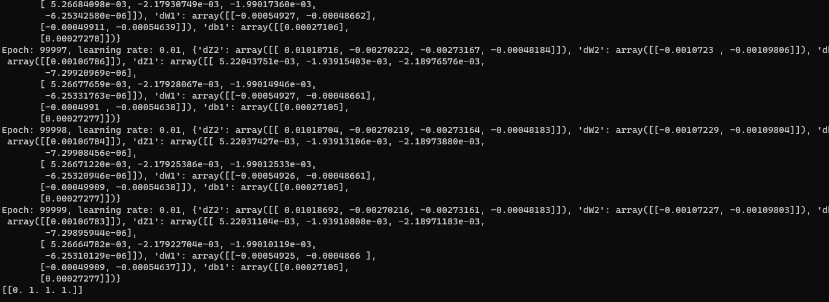

LAB 8
Backpropagation Learning

Submitted by: Submitted to:
Nabin Katwal Deepak Bhatt
Class of 2022 Artificial Intelligence
Roll No: 824

INTRODUCTION
Backpropagation (backward propagation) is an important mathematical tool for improving the accuracy of predictions in data mining and machine learning. Essentially, backpropagation is an algorithm used to calculate derivatives quickly.
Artificial neural networks use backpropagation as a learning algorithm to compute a gradient descent with respect to weights. Desired outputs are compared to achieve system outputs, and then the systems are tuned by adjusting connection weights to narrow the difference between the two as much as possible. The algorithm gets its name because the weights are updated backwards, from output towards input.
The difficulty of understanding exactly how changing weights and biases affects the overall behavior of an artificial neural network was one factor that held back wider application of neural network applications, arguably until the early 2000s when computers provided the necessary insight. Today, backpropagation algorithms have practical applications in many areas of artificial intelligence (AI), including optical character recognition (OCR), natural language processing (NLP) and image processing.
Because backpropagation requires a known, desired output for each input value in order to calculate the loss function gradient, it is usually classified as a type of supervised machine learning. Along with classifiers such as Naïve Bayesian filters and decision trees, the backpropagation algorithm has emerged as an important part of machine learning applications that involve predictive analytics.
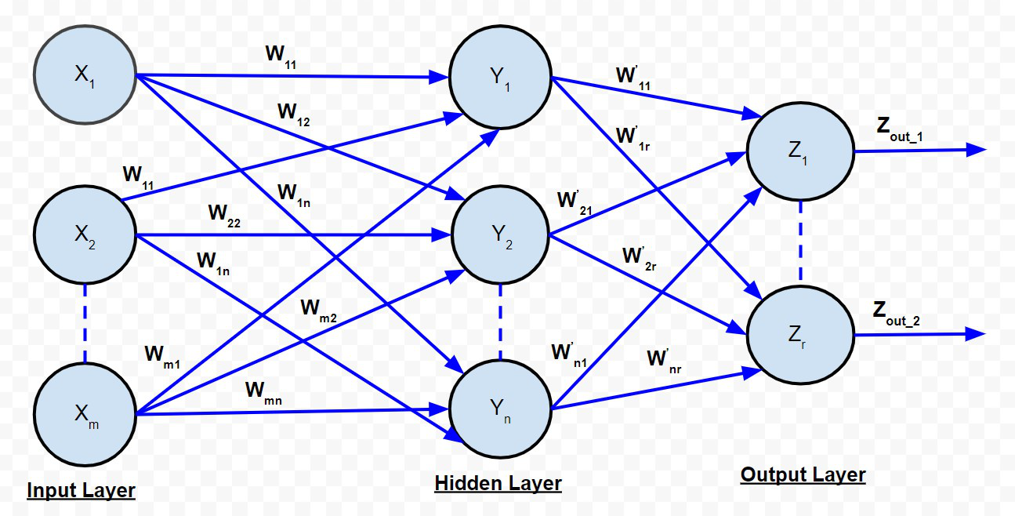
PROGRAM CODE
import numpy as np

class NeuralNetwork(object):
def __init__(self, layers = [2,10,1], activations = ['sigmoid', 'sigmoid']):
assert(len(layers) == len(activations)+1)
self.layers = layers
self.activations = activations
self.weights = []
self.biases = []
for i in range(len(layers)-1):
self.weights.append(np.random.randn(layers[i+1], layers[i]))
self.biases.append(np.random.randn(layers[i+1],1))

def feedforward(self, x):
a = np.copy(x)
z_s = []
a_s = [a]
for i in range(len(self.weights)):
activation_function = self.getActivationFunction(self.activations[i])
z_s.append(self.weights[i].dot(a)+self.biases[i])
a = activation_function(z_s[-1])
a_s.append(a)
return (z_s, a_s)

@staticmethod
def getActivationFunction(name):
if name == 'sigmoid':
return lambda x:np.exp(x)/(1+np.exp(x))
elif name == 'linear':
return lambda x:x
elif name == 'relu':
def relu(x):
y = np.copy(x)
y[y<0] = 0
return y
return relu
else:
print('Unknown activation function, linear is used')
return lambda x:x

@staticmethod
def getDerivitiveActivationFunction(name):
if name == 'sigmoid':
sig = lambda x: np.exp(x)/(1+np.exp(x))
return lambda x:sig(x)*(1-sig(x))
elif name == 'linear':
return lambda x:1
elif name == 'relu':
def relu_diff(x):
y = np.copy(x)
y[y>=0]=1
y[y<0] = 0
return y
return relu_diff
else:
print('Unknown activation function. linear is used')

def backpropagation(self, y, z_s,a_s):
dw =[]
db = []
deltas = [None] * len(self.weights)
deltas[-1] =((y-a_s[-1])*(self.getDerivitiveActivationFunction(self.activations[-1]))(z_s[-1]))
for i in reversed(range(len(deltas)-1)):
deltas[i] = self.weights[i+1].T.dot(deltas[i+1])*(self.getDerivitiveActivationFunction(self.activations[i])(z_s[i]))
batch_size = y.shape[1]
db = [d.dot(np.ones((batch_size,1)))/float(batch_size) for d in deltas]
dw = [d.dot(a_s[i].T)/float(batch_size) for i,d in enumerate(deltas)]

def train(self, x, y, batch_size = 10, epochs=100, lr=0.01):
for e in range(epochs):
i=0
while(i<len(y)):
x_batch = x[i:i+batch_size]
y_batch = y[i:i+batch_size]
i = i+batch_size
z_s, a_s = self.feedforward(x_batch)
dw, db = self.backpropagation(y_batch, z_s, a_s)
self.weights = [w+lr*dweight for w,dweight in zip(self.weights, dw)]
self.biases = [w+lr*dbias for w,dbias in zip(self.biases, db) ]
print("loss = {}".format(np.linalg.norm(a_s[-1]-y_batch)))

if __name__ == '__main__':
import matplotlib.pyplot as plt
nn = NeuralNetwork([1,100,1], activations=['sigmoid', 'sigmoid'])
X = 2*np.pi*np.random.rand(1000).reshape(1,-1)
y = np.sin(X)

nn.train(X, y, epochs = 1000, batch_size = 64, lr=0.1)
_,a_s = nn.feedforward(X)

plt.scatter(X.flatten(), y.flatten())
plt.scatter(X.flatten(), a_s[-1].flatten())
plt.show()

Output
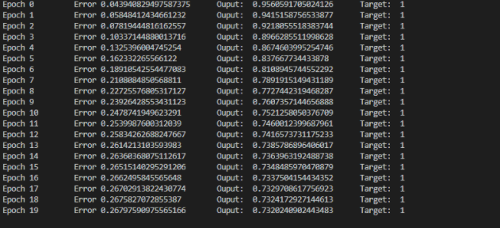

LAB 10
NLTK(Splitting Words from a sentence)

Submitted by: Submitted to:
Nabin Katwal Deepak Bhatt
Class of 2022 Artificial Intelligence
Roll No: 824

INTRODUCTION
NLTK is a leading platform for building Python programs to work with human language data. It provides easy-to-use interfaces to over 50 corpora and lexical resources such as WordNet, along with a suite of text processing libraries for classification, tokenization, stemming, tagging, parsing, and semantic reasoning, wrappers for industrial-strength NLP libraries
PROGRAM CODE
import nltk

sentence = "At eight o'clock on Thursday morning Arthur didn't feel very good"
tokens = nltk.word_tokenize(sentence)
print(tokens)
tagged = nltk.pos_tag(tokens)
print(tagged)

OUTPUT
References:
- https://www.nltk.org/
- https://searchenterpriseai.techtarget.com/definition/backpropagation-algorithm

